**Lab 4**

**Name:** Farhan Bukhari

**Section:** BCS-5F1

**Roll No.** 21-5247

**Lab Statement 1**

**Q1:**

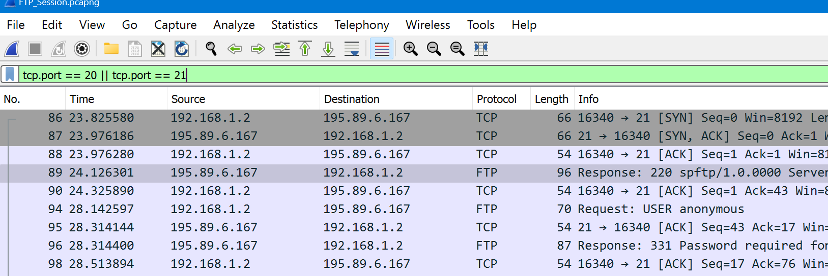

Port 20 is typically associated with the FTP (File Transfer Protocol) data transfer process. FTP is a commonly used protocol for transferring files over a network. Port 21, on the other hand, is used for the FTP control connection, which is responsible for establishing and managing the FTP session.

**Q2:**

**Frame Number:** 89

**Source:** 195.89.6.167**, Destination:** 192.168.1.2

Received response indicating that the SMTP service is ready for the next command.

**Response Code:** 220 (Service ready for new user)

**Response argument:** spftp/1.0.0000 Server [195.89.6.167]

**Frame Number:** 94

**Source:** 192.168.1.2**, Destination:** 195.89.6.167

Requesting the USER command with the argument "anonymous".

**Response Code:** USER

**Response argument:** anonymous

**Frame Number:** 96

**Source:** 195.89.6.167**, Destination:** 192.168.1.2

Server response indicating the need for a password.

**Response Code:** 331 (User name okay, need password)

**Response argument:** Password required for USER

**Frame Number:** 99

**Source:** 192.168.1.2**, Destination:** 195.89.6.167

Providing an empty password.

**Response Code:** PASS

**Response argument:** N/A

**Frame Number:** 100

**Source:** 195.89.6.167**, Destination:** 192.168.1.2

Server warning the client about restricted access.

**Response Code:** 230

**Response argument:** 230- WARNING: This is a restricted access system. If you do not have explicit permission to access this system, please disconnect immediately.

**Frame Number:** 104

**Source:** 192.168.1.2**, Destination:** 195.89.6.167

Requesting the activation of port 16340.

**Response Code:** PORT

**Response argument:** 192,168,1,2,63,213

**Frame Number:** 105

**Source:** 195.89.6.167**, Destination:** 192.168.1.2

Server confirming the success of the previous port command.

**Response Code:** 200 (Command okay)

**Response argument:** PORT command successful.

**Frame Number:** 106

**Source:** 192.168.1.2**, Destination:** 195.89.6.167

Sending the NLST command.

**Response Code:** NLST

**Response argument:** N/A

**Frame Number:** 107

**Source:** 195.89.6.167**, Destination:** 192.168.1.2

Server indicating the opening of an ASCII mode data connection for the root directory ("/").

**Response Code:** 150 (File status okay; about to open data connection)

**Response argument:** Opening ASCII mode data connection for /.

**Frame Number:** 125

**Source:** 195.89.6.167**, Destination:** 192.168.1.2

Transfer of data is complete.

**Response Code:** 226 (Closing data connection)

**Response argument:** Transfer Complete

**Frame Number:** 127

**Source:** 195.89.6.167**, Destination:** 192.168.1.2

**FTP data:** 125 bytes transferred using PORT and NLST commands.

**Frame Number:** 151

**Source:** 192.168.1.2**, Destination:** 195.89.6.167

Requesting the port command.

**Response Code:** PORT

**Response argument:** 192,168,1,2,63,214

**Frame Number:** 152

**Source:** 195.89.6.167**, Destination:** 192.168.1.2

Server confirming the success of the port command.

**Response Code:** 200 (Command okay)

Response argument: PORT command successful

**Frame Number:** 153

**Source:** 192.168.1.2**, Destination:** 195.89.6.167

Requesting the retrieval of the file "legal.txt".

**Response Code:** RETR

**Response argument:** legal.txt

**Frame Number:** 155

**Source:** 195.89.6.167**, Destination:** 192.168.1.2

Response indicating the opening of an ASCII mode data connection for the file "illegal.txt".

**Response Code:** 150

**Response argument:** Opening ASCII mode data connection for illegal.txt

**Frame Number:** 160

**Source:** 195.89.6.167**, Destination:** 192.168.1.2

Response indicating the completion of the data transfer.

**Response Code:** 226 (Closing data connection)

**Response argument:** Transfer complete

**Frame Number:** 161

**Source:** 195.89.6.167**, Destination:** 192.168.1.2

FTP data: 1415 bytes transferred using PORT and RETR commands.

**Frame Number:**173

**Source:** 192.168.1.2**, Destination:** 195.89.6.167

Client requesting to quit the FTP session.

**Response Command:** QUIT

**Frame Number:** 175

**Source:** 195.89.6.167**, Destination:** 192.168.1.2

Server indicating the closure of the control connection.

**Response Code:** 221 (Service Closing Control Connection)

**Response argument:** Goodbye

**Lab Statement 3**

**Q1**

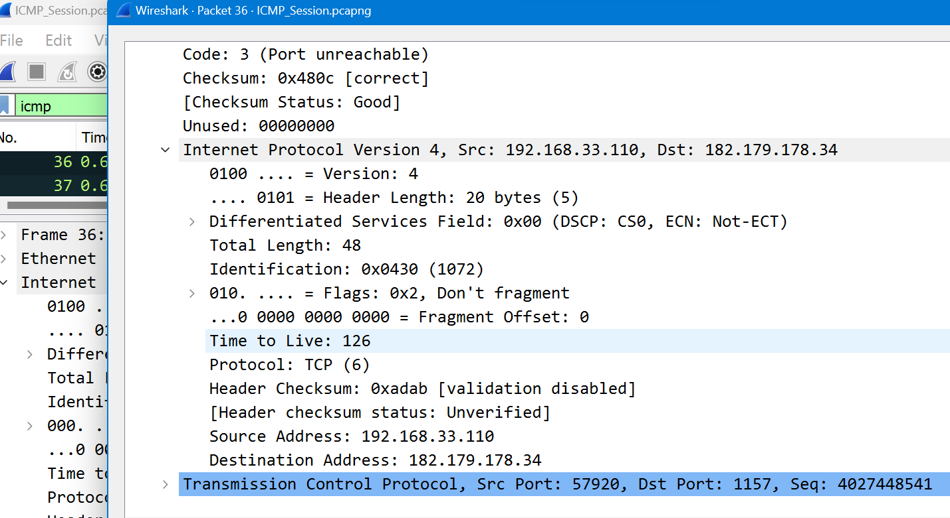

Therefore, the data is transferred through TCP Protocol

**Q2**

Ethernet Address is:



**Q3**

**ECHO** requests are being sent through packets.

**Q4**

Host is sending 4 requests.

**Q5**

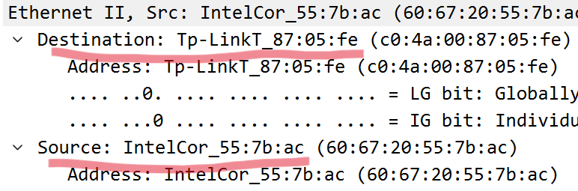

**Q6**

ICMP (Internet Control Message Protocol) packets do not have source and destination port numbers because ICMP operates at the IP (Internet Protocol) layer, which is a lower layer than the transport layer where port numbers are used.

**Q7**

These are differentiated on following basis:

**ICMP Echo Request**: The ICMP Type value for an Echo Request message is typically 8. This message is used to request an Echo Reply from the destination device.

**ICMP Echo Reply**: The ICMP Type value for an Echo Reply message is usually 0. It is sent by the destination device in response to an Echo Request.

Also the ICMP identifiers and sequence numbers are different.

**Q8**

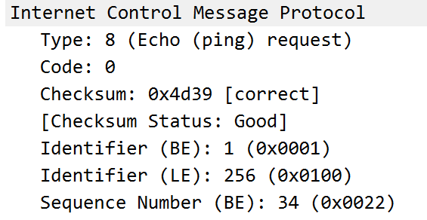

**Q9**

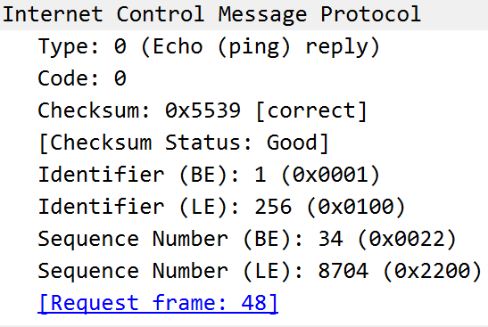

**Q10**

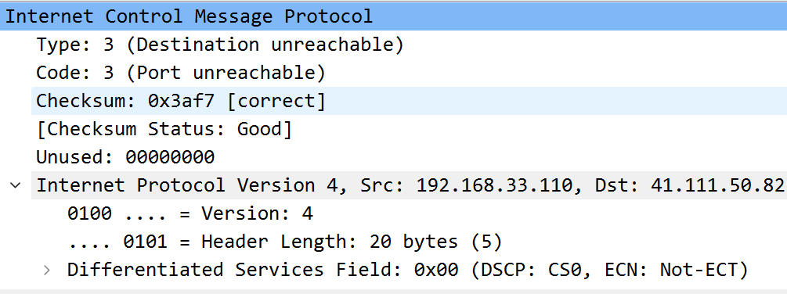

In some ICMP (Internet Control Message Protocol) packets, the IP (Internet Protocol) and TCP (Transmission Control Protocol) headers may be included as part of the ICMP header for specific types of ICMP messages. This is known as an ICMP error message. It occurs when destination in unreachable.